**VISVESVARAYA TECHNOLOGICAL UNIVERSITY**

**BELAGAVI, KARNATAKA**



*A Mini Project Report*

***(Fifth semester)***

*on*

**“VOICE BASED LIBRARY MANAGEMENT SYSTEM”**

Submitted in the partial fulfillment for the requirements for the conferment of degree of

**BACHELOR OF ENGINEERING**

in

**INFORMATION SCIENCE AND ENGINEERING**

By

|  |  |
| --- | --- |
| **Mr. RAGHAVENDRA K M** | USN: 1BY18IS093 |
| **Ms. SANJANA GAJANANA SHETTY** | USN: 1BY18IS104 |

Under the guidance of

**Dr. Drakshaveni G**

Associate Professor

Dept of MCA



**2020-2021**

**BMS INSTITUTE OF TECHNOLOGY & MANAGEMENT**

**YELAHANKA, BANGALORE – 560064**

**DEPARTMENT OF INFORMATION SCIENCE & ENGINEERING**



**CERTIFICATE**

This is to certify that the Mini Project (Fifth Semester) entitled **“Voice Based library management system”** is a bonafide work carried out  **Mr. Raghavendra K M (1BY18IS093), Ms. Sanjana Gajanana Shetty (1BY18IS104)** in partial fulfillment for the award of **Bachelor of Engineering Degree in Information Science and Engineering** of the Visvesvaraya Technological University, Belagavi during the year 2020-21. It is certified that all corrections/suggestions indicated for internal assessment have been incorporated in this report. The mini project report has been approved as it satisfies the academic requirements with respect to mini project work for the B.EDegree.

|  |  |  |
| --- | --- | --- |
| ______________________ | _________________________ | ______________________ |
| **Signature of the guide**  Dr. Drakshaveni G | **Signature of the examiner** | **Signature of the HOD**  Dr. Pushpa S. K |

**ACKNOWLEDGEMENT**

We are happy to present this Mini Project after completing it successfully. This Mini Project would not have been possible without the guidance, assistance and suggestions of many individuals. We would like to express our deep sense of gratitude and indebtedness to each and everyone who has helped us make this Mini Project a success.

We are grateful to **Dr. Mohan Babu G N,** Principal, BMS Institute of Technology & Management for his constant encouragement and support.

We heartily thank **Dr. Pushpa S K,** Head of the Department, Information Science and Engineering, for her constant encouragement and inspiration in taking up this project.

We sincerely thank **Dr. Manjunath T N**, Professor, Dept. of Information Science and Engineering and Dean (External Relations) for his constant support and motivation.

We gracefully thank our guide**, Dr. Sheela Kathavate,** Associate Professor, Dept. of Information Science and Engineering, for her encouragement and advice throughout the course of this project work.

Nevertheless, we express our gratitude towards our family and friends for the encouragement and support which helped us to finish this project successfully.

By,

**Raghavendra K M**

**Sanjana Gajanana Shetty**

**DECLARATION**

We, hereby declare that the Mini Project titled “**VOICE BASED LIBRARY MANAGEMENT SYSTEM**” is a record of original Mini Project work undertaken for the award of the degree of Bachelor of Engineering in Information Science and Engineering of the Visvesvaraya Technological University, Belagavi during the year 2020-21. We have completed this Mini Project work under the guidance of Mrs. Drakshaveni, Assistant professor, Dept. of MCA.

We also declare that this Mini Project report has not been submitted for the award of any degree, diploma, fellowship or other title anywhere else.

|  |  |  |
| --- | --- | --- |
|  |  |  |
| Raghavendra K M  1BY18IS093 |  | Sanjana Gajanana Shetty  1BY18IS104 |

**ABSTRACT**

As the number of books in a library increases, the workload on the librarians to maintain the valuable books also increases. Not just for the library admins, the burden of searching books is also faced by students and faculty. There are various problems also faced by the student in the library such as finding any particular book, information whether book is available or not, for what time this book will be available, searching for books using ISBN number etc. To eliminate this manual system, a computerised library management system has been proposed.

“Voice Based Library Management System” is a system which maintains the information about the books present in the library, their authors, the users of a library to whom books are issued, library staff and all. This is very difficult to organize manually. Maintenance of all this information manually is a very complex task. Owing to the advancement of technology, organization of a Library becomes much easier.

The voice-based Library Management System has been designed to computerize and automate the operations performed over the information about the members, book issues and returns and all other operations. This computerization of a library helps in many instances of its maintenance. It reduces the workload of management as most of the manual work done is reduced

The digitalised library management system will have features like:

1. Easy updation of the database whenever a student borrows a book or returns a book.
2. A voice-based search system which can help students as well as faculty in searching for the books.
3. Categorisation of books in genres based on title.
4. Information about validity period of the issued book.

**TABLE OF CONTENTS**

**Chapter 1 Introduction Page No**

1.1 Outline 1

1.2 Motivation and scope 1

1.3 Problem Statement 1

1.4 Limitations 1

**Chapter 2 Requirement Specification**

2.1 Functional Requirements 2

2.2 Non-Functional Requirements 3

2.3 Domain Constraints 4

**Chapter 3 System and Requirements Analysis**

3.1 Overall System Description 5

3.2 Display Module 10

3.3 Update Module 10

3.4 Deletion Module 11

**Chapter 4 System Design**

4.1 Entity Relationship Diagram 12

4.2 Schema Diagram 12

**Chapter 5 Implementation**

5.1 Description of Database Used 13

5.2 Description of Implementation 13

**Chapter 6 Testing**

6.1 Component Tests 16

6.2 System Tests 18

**Chapter 7 Interpretation of Results** 19

**Conclusion** 27

**Reference**  28

**List of Figures/Tables**

|  |  |  |
| --- | --- | --- |
| **Chapter No.** | **Name of Figures** | **Page No.** |
| 3.1 | Overall System Design | 05 |
| 3.2 | Display Process Flow Diagram | 10 |
| 3.3 | Update Process Flow Diagram | 10 |
| 3.4 | Deletion Process Flow Diagram | 11 |
| 4.1 | Entity Relationship Diagram | 12 |
| 4.2 | Schema Diagram | 12 |
| 7.1 | Login Page | 19 |
| 7.2 | Registration Page | 19 |
| 7.3 | View book page | 20 |
| 7.4 | Borrow book page (Student login) | 20 |
| 7.5 | Return book page (Student login) | 21 |
| 7.6 | Dashboard page (Student login) | 21 |
| 7.7 | Authors tab in Manage page (Staff login) | 22 |
| 7.8 | Publishers tab in Manage page (Staff login) | 22 |
| 7.9 | Books tab in Manage page (Staff login) | 23 |
| 7.10 | Search Results Page | 23 |
| 7.11 | Add book page | 24 |
| 7.12 | Dashboard page (Staff login) | 24 |
| 7.13 | Updated Author Page (Staff Login) | 25 |
| 7.14 | After deletion of a book | 25 |
| 7.15 | Admin Panel | 26 |
| 7.16 | Records in BOOK Table | 26 |

|  |  |  |
| --- | --- | --- |
| **Chapter No.** | **Name of Tables** | **Page No.** |
| 6.1 | User Login Module Test | 16 |
| 6.2 | Student Registration Module Test | 16 |
| 6.3 | Borrow book Module Test | 16 |
| 6.4 | Return book Module Test | 17 |
| 6.5 | Search Module Test | 17 |
| 6.6 | System Test | 18 |

**CHAPTER 1**

**INTRODUCTION**

**1.1 Outline**

A Voice Based Library Management System is a software that has been developed to handle basic housekeeping functions of a library. It’s a well-organized software solution for a Library Management System.It helps to provide information on any book present in a library to the user as well as for staff. It keeps a track of borrowed, returned and added books to the library.

This system is concerned with developing a library management system using database software. In this system the library management becomes more efficient and easier to handle with its reliable system components. A voice-based library system was developed in order to computerise the borrowing and returning of books, return books, and add books, search books and special tools like voice-based book search.

Library automation is the general term for information and communication technologies that are used to replace manual systems in the library. When the library management System shares a common database to perform all the basic functions of a library, the system is integrated to make the existing system more efficient. To provide a user-friendly environment where users can be serviced better. Make the library functioning faster.

**1.2 Motivation and Scope**

The library as an integral and significant part of educational system. Previous System was time wasting because of providing the insufficient features to students like only one book per students, there is no search engine facility, sometimes user might be searching for a book that is not available in the library in such situations people get irritated and waste their time. In manual system we generally use the issue cards for issuing the book or if the card has been lost then we have to make a new card again which take time and till then student have to wait and search the database again for the student information which is complicated. On the other hand, keeping large amount of maintenance workers may cost a lot & it will not be efficient for a library.

Manual record keeping is also not a reliable method as people tend to forget things. Modify the details of students/books is large process and may lead prone to errors. Accession number of the book is calculated manually by looking up into previous records which requires a lot of manpower and if the book is lost then the entry of the book is to be deleted from all the register which is a complex task.

**1.3 Problem Statement**

Computerization of Library Activities and Book Transactions Design a system for library management system for Andaman college that has voice-based search of books and automatic categorization of books in genres based on title. The system should search from the internet and get information about the book and put them into appropriate category based on title, authors and information collected online.

**1.4 Limitations**

* The project currently runs on a locally hosted server; hence it cannot reflect the changes.
* User won’t receive the notification about due date.
* Currently due fines are not calculated and nformed to the user.
* SQLite is used to handle low to medium traffic HTTP requests.

**CHAPTER 2**

**REQUIREMENT SPECIFICATION**

**2.1 Functional Requirements**

**Request for Login**

The system shall require a user to register, in order to carry out the main objective of the system. It will ask the user for the following information like user name, password, etc. If correct, the system allows the user to carry out further operations. While registering for the first time, a user should enter an email id which is not present in the database.

**Staff Login**

A staff needs to register and login to the system, to manage the books in the library.

**Admin Login**

Admin can login and manage the entire database. Restricting a staff registration is a special privilege given to the admin.

**Web browser**

A Web Browser is a software application for accessing information on the world wide web. Each individual web page, image, and video is identified by the distinct URL, enabling browsers to retrieve and display them on the user’s device.

**2.2 Non-Functional Requirements**

**Performance**

Response time of the System should be less than 3 second most of the time. Response time refers to the waiting time while the system accesses, queries and retrieves the information from the databases. (DB-user, DB-schedule etc)

**Reliability**

* It shall be available 24 hours a day, 7 days a week
* It shall always provide accurate status of the registered complaints.
* This software shall be robust enough to have a high degree of fault tolerance.

For example, if the user enters a wrong password, the system should not crash and shall identify the invalid input and produce a suitable error message.

* The application shall be able to recover from power failures and other natural catastrophes and rollback the databases to their most recent valid state.

**Usability**

It shall provide an easy-to-use graphical interface similar to other existing registration systems so that the users do not have to learn a new style of interaction. Any notification or error messages generated by the website shall be clear, succinct and polite.

**Integrity**

Only the system administrator has the right to change system parameters, such as complaint categories, complaint status etc. The system should be secure and must use encryption to protect the databases. Users need to be authenticated before having access to any data.

**Interoperability**

The website shall minimize the effort required to couple it to another system, such as the Course management database system.

**2.3 Domain Constraints**

* **Regulatory policies:** It is mandatory that no text box must be left empty or contains insufficient data.
* **Hardware limitations:** There must be a 64 MB on board memory
* **Control functions:** The software must be very user-friendly and display appropriate error messages.
* **Interfaces to other applications:** Not applicable.
* **Parallel operations:** It must support many users simultaneously.
* **Software Requirement:**
  + Operating System- Windows/Mac/Ubuntu
  + Browser- Chrome/Mozilla Firefox/Internet Explorer
* **Hardware Requirement:**
  + Processor- 32 or 64bit
  + Memory- 2GB RAM
  + Hard Disk- 100Mb

**CHAPTER 3**

**SYSTEM/ REQUIREMENT ANALYSIS**

**3.1 Overall System Description**

Update data

Admin login

Student login

Staff login

home

Logged in successfully

Logged in successfully

Option of

performing

any query

Option of

performing

any query

Retrieve

data

Insert data

Delete data

Data accessed

**Fig. 3.1 Overall System Design**

**Modules in the system**

**1. Student**

**1.1 Signup**

Each student has to provide his official college domain email id, University Serial Number, and other details like name, course, semester etc. After filling up the registration form provided to the student, he/she can login or signin to the system.

And if the student fails to enter valid details in the form, the system will repond back saying “Enter a valid data”.

**1.2 Signin**

After successful registration process, students can authenticate in to the system. If the user login credentials are incorrect or invalid, the system will alert the user. And if the user login credentials are valid, the system will redirect the user to his/her Dashboard.

**1.3 Dashboard**

Dashboard of a user can also be realised as the Home page which is common in most of the websites. Here a particular user can quicky view the Books which are borrowed and returned. Users can also navigate to different pages using the top navigation bar provided in the site. Two separate tables can be observed in the body of Dashboard, one which displays the borrowed books and the other for returned books.

**1.4 Borrow book**

Borrow book is the location where the user can find all the books which are currently available in the library. He/she can even search for a particular book, inside the books table. Here, users can view all book details. If the user wishes to learn more about the book, he/she needs to click on the title of the book. Note: A global search option is also provided for the user, which is integrated with voice search.

**1.5 View book**

View book is the webpage which is retrieved everytime, when the user clicks on a book title. He/she can find the book title links in Dashboard, Borrow book, Return book, Search Result Page. This page contains all the information of a particular book and the option to Borrow or Return the book. *Borrow book* button can be pressed only when the user has not borrowed the book. *Return book* can be pressed only when the user has borrowed the book.

**1.6 Return book**

Return book page provides user with information related to all the books which are borrowed by him/her.

**1.7 Search box**

Search box is the input field, which is used for knowing about a book or finding whether it exists in the library or not. Here, the user need not enter the entire title of a book. Users can retrieve information related to a book, just by entering the few starting letters in the book title.

Another speciality of the Search box, is the Voice based search. Users here no need to type the book title. He/she can just click on the microphone icon, which is located adjacent to the search box. Whenever the sytem is ready to listen to the user, it will create pulse animations. This gives the ease of access to the user in searching for a particular book in the library system.

**1.8 Signout**

The user can logout or signout, so that he/she can prevent unauthorised access to his/her account. This option is provided in the dropdown menu of the username button. Username button is located in top most navigation bar.

**2. Staff**

**2.1 Signup**

Staff signup is alike Student signup. So, the system needs to authorise the user. That is why, any staff who needs to register in to the system needs to initially contact the system administrator. A staff can only register if and only if the sytem admin inserts his/her email in to the STAFF table.

Each staff has to provide his official college domain email id, and other details like name, address, salary etc. After filling up the registration form provided to the staff, he/she can login or signin to the system.

And if the staff fails to enter valid details in the form, the system will repond back saying “Enter a valid data”.

**2.2 Signin**

After successful registration process, staff or librarian can authenticate in to the system. If the user login credentials are incorrect or invalid, the system will alert the user. And if the user login credentials are valid, the system will redirect the user to his/her Dashboard.

**2.3 Dashboard**

Dashboard of a user can also be realised as the Home page which is common in most of the websites. Here a particular user can quicky view the all Books which are borrowed and returned by the students. Users can also navigate to different pages using the top navigation bar provided in the site. Two separate tables can be observed in the body of Dashboard, one which displays the borrowed books and the other for returned books.

**2.4 Manage**

Manage page is the facility provided only for the staff and admin users. This page contains information related to AUTHOR, PUBLISHER, BOOK and STOCK table. The information is displayed in a very ordered manner. User can retrieve the data from the tables by clicking upon the three tabs which are down below the navgation bar. Authors, Publishers and Books are the three tabs present here. And in every tab the user can perform Create, Read, Update and Delete (CRUD) operations efficiently.

For example, say by clicking Publisher the user can perform CRUD in the PUBLISHER table.

Users can view all the records of the table, insert new publishers, update any existing publisher record, delete any existing publisher.

Viewing all the publisher records: All the records in the table is displayed in the body of the page.

Insert new publisher: The option to insert a new record into the table can be accessed by clicking upon the *Add Publisher* button.

Update existing publisher: The option to update existing record in the table can be accessed by clicking upon the *Update* button. The *Update* button is a dropdown item, so by tapping upon *Action* button, users can access it.

Delete existing publisher: The option to delete existing record in the table can be accessed by clicking upon the *Delete* button. The *Delete* button is a dropdown item, so by tapping upon *Action* button, users can access it.

Note: The user interface for Authors, Publishers and Books is same i.e., the HTML elements arrangement for performing CRUD operationd in the tabs of Authors, Publishers and Books are similar.

**2.5 View book**

View book is the webpage which is retrieved everytime, when the user clicks on a book title. He/she can find the book title links in Dashboard, Manage, Search Result Page. This page contains all the information of a particular book and the option to Borrow or Return the book. *Borrow book* and *Return book* buttons are by default disabled to staff or librarian.

**2.6 Search box**

Search box is the input field, which is used for knowing about a book or finding whether it exists in the library or not. Here, the user need not enter the entire title of a book. Users can retrieve information related to a book, just by entering the few starting letters in the book title.

Another speciality of the Search box, is the Voice based search. Users here no need to type the book title. He/she can just click on the microphone icon, which is located adjacent to the search box. Whenever the sytem is ready to listen to the user, it will create pulse animations. This gives the ease of access to the user in searching for a particular book in the library system.

**2.7 Signout**

The user can logout or signout, so that he/she can prevent unauthorised access to his/her account. This option is provided in the dropdown menu of the username button. Username button is located in top most navigation bar.

**3. Administrator (Admin)**

Admin can also be called as the superuser of the system. He has the control over every tables in the database.

The relationship between Staff user and Admin user can be interpreted in a simple way by using mathematical concept of sets. If Staff and Admin are the two sets, Staff is the subset of Admin set. So, here we can come to the conclusion that, all the operations and privileges which can be performed by the Staff can also be performed by the Admin user. But it’s not vice versa!

Admin has the special permission to manage the Staff registration. STAFF is a table in the database, which holds the records(emails) of the staff or librarians who can register into the system. Due to this functionality of the system, whenever a staff wants to register into the system, he/she will need to contact admin.

**User Privileges:**

**1. Student**

Every student user can,

1. Borrow available books from the library
2. Return borrowed books
3. View all the borrowed books
4. View all the returned books
5. Search for books in the library.

Every student user cannot,

1. Perform insert, update and delete operations in AUTHOR, PUBLISHER, BOOK and STOCK tables.

**2. Staff**

Every staff user can,

1. View all the records into AUTHOR, PUBLISHER, BOOK and STOCK tables.
2. Insert records into AUTHOR, PUBLISHER, BOOK and STOCK tables.
3. Update records into AUTHOR, PUBLISHER, BOOK and STOCK tables.
4. Delete records into AUTHOR, PUBLISHER, BOOK and STOCK tables.
5. View all the records from BORROWED_BOOK table.
6. Search for books in the library.

Every staff user cannot,

1. Borrow or return book from the library.

**3. Admin**

Every admin user can,

1. Perform CRUD operations in all the tables.

**3.2 Display Module**

The system reads data stored in the database to display varoius information requested by a particular user.

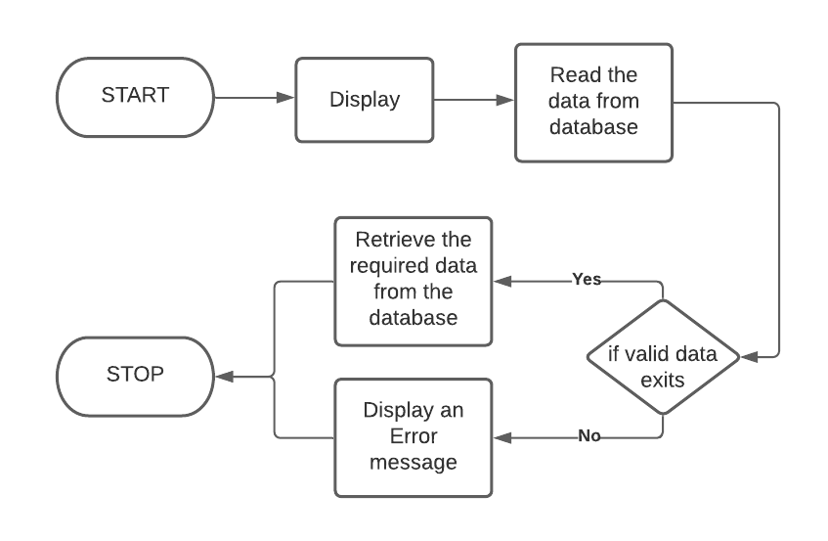

**Fig. 3.2 Display Process Flow Diagram**

**3.3 Update Module**

The system updates data stored in the database to modify or change varoius information requested by a particular user using this module.

Staff and Admin are the two types of user, who have the privileges of updating data.

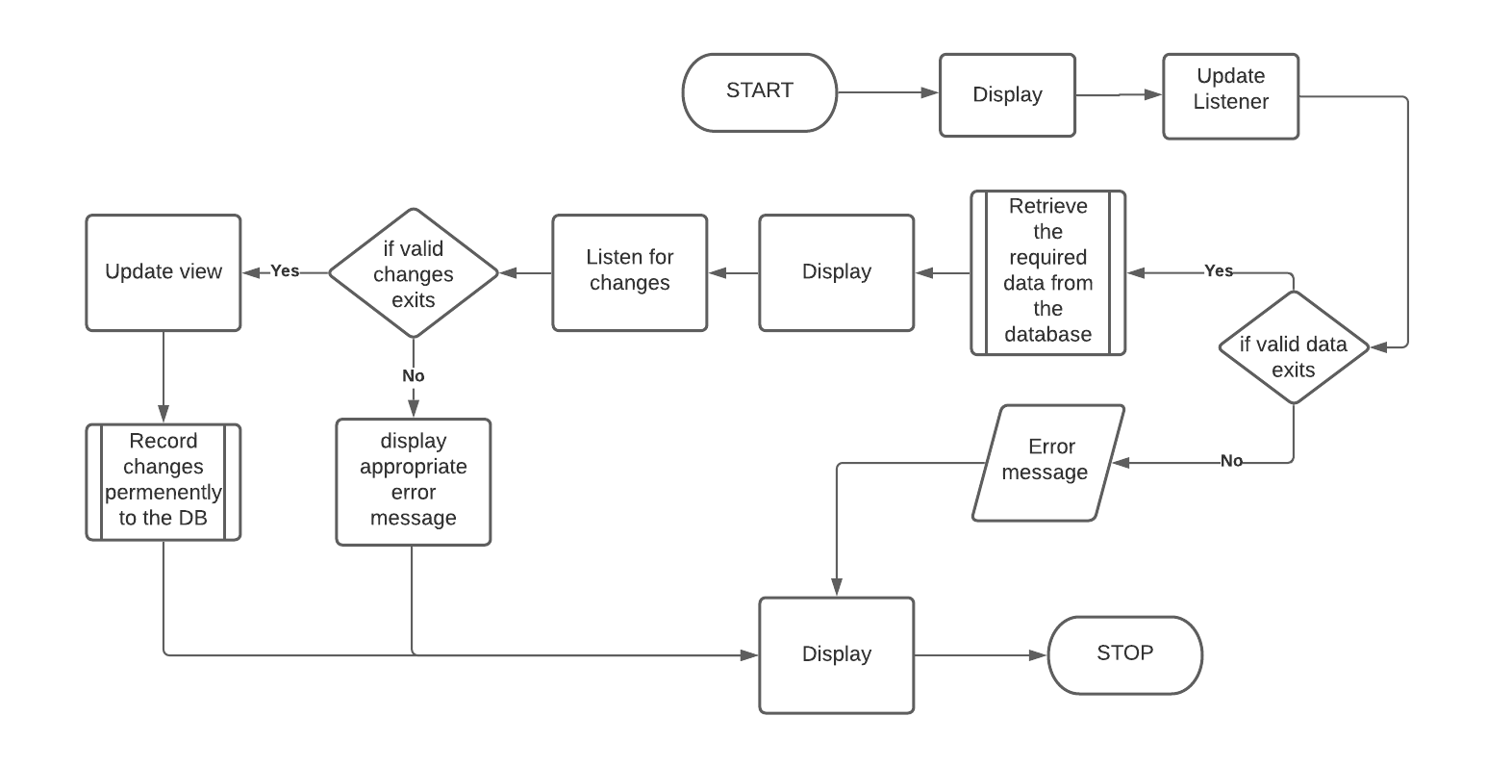

**Fig. 3.3 Update Process Flow Diagram**

**3.4 Deletion Module**

In Deletion mode the admin and staff have the right to delete records from the BOOK, AUTHOR, PUBLISHER and STOCK.

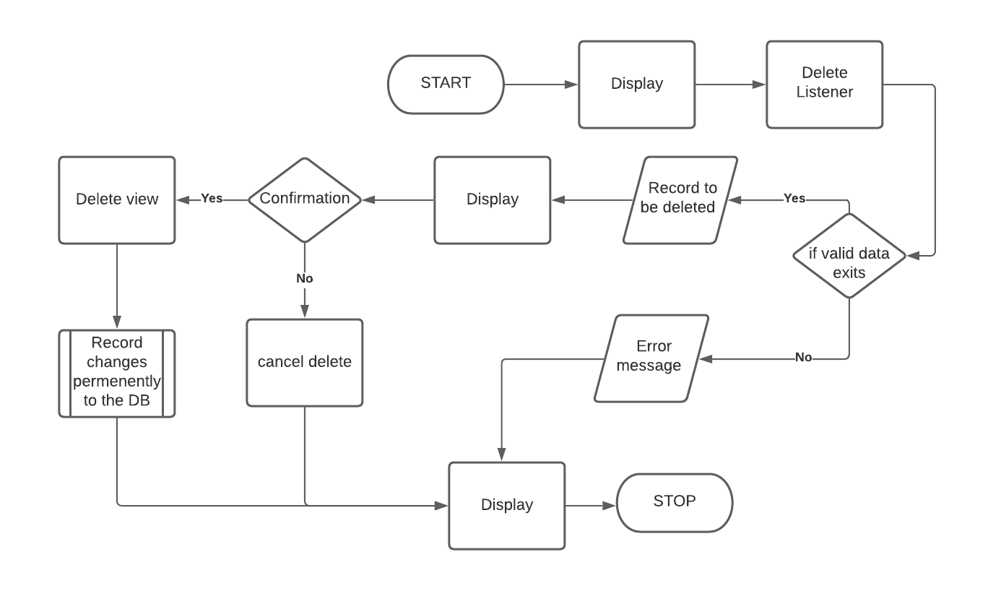

**Fig. 3.4 Deletion Process Flow Diagram**

**CHAPTER 4**

**SYSTEM DESIGN**

**4.1 Entity Relationship Diagram:**

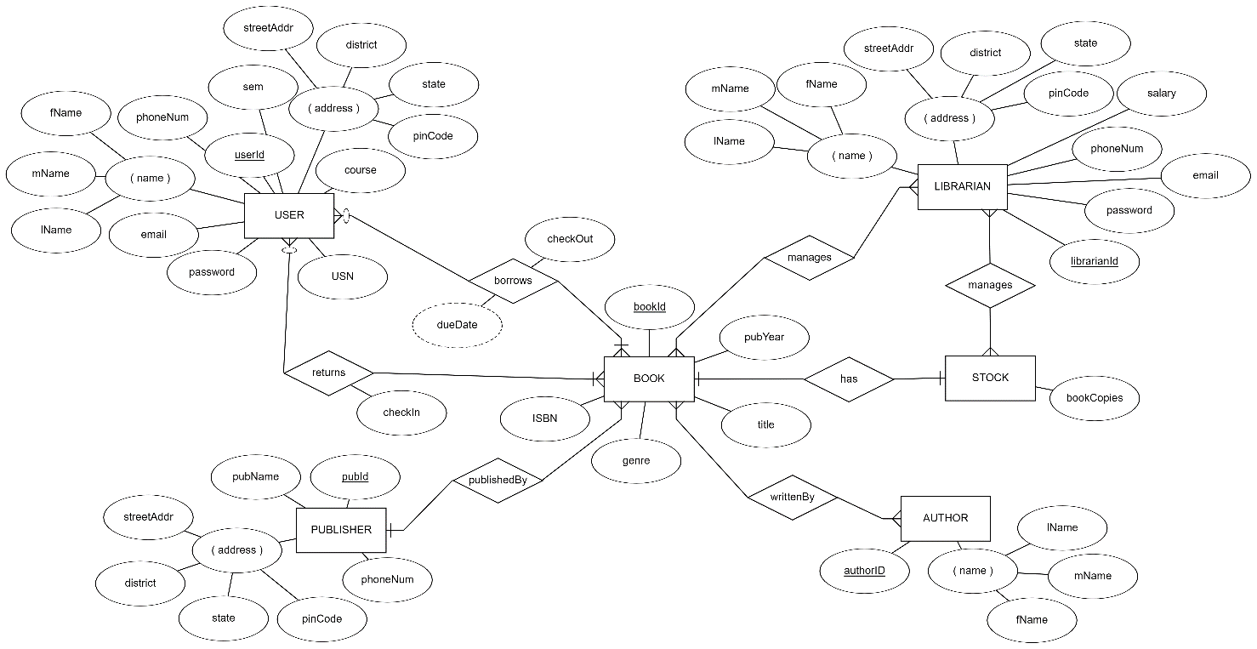

*Fig. 4.1 Entity Relationship Diagram*

**4.2 Schema Diagram**

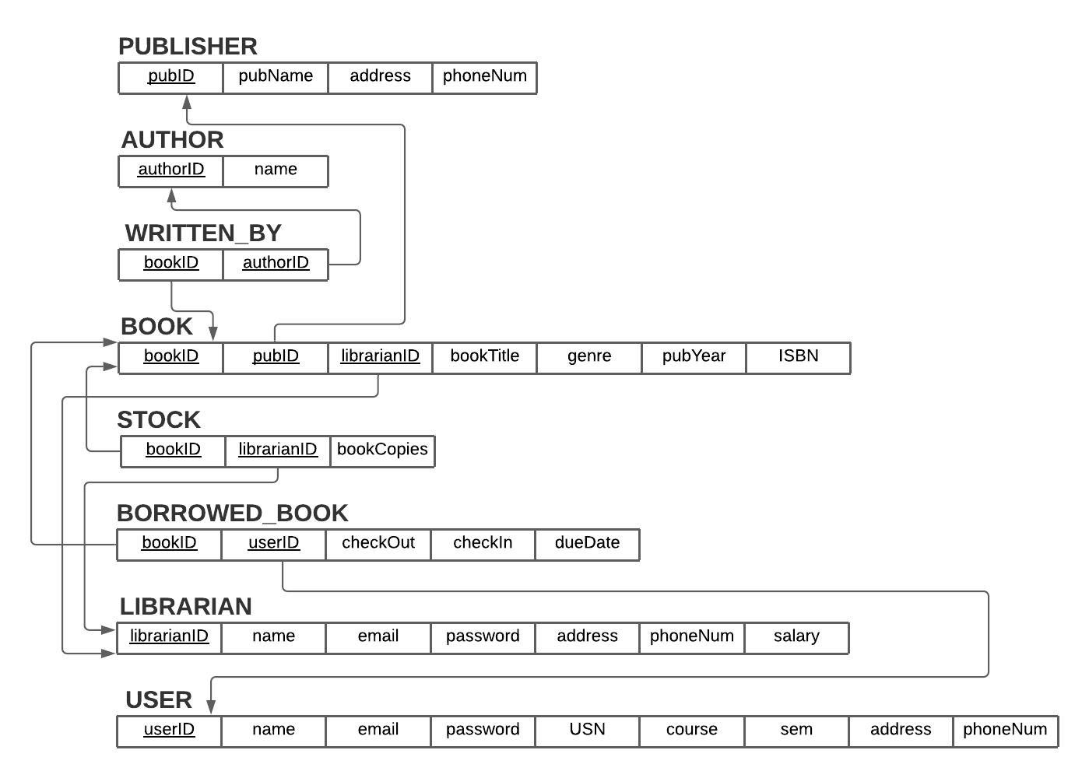

*Fig. 4.2 Schema Diagram*

**CHAPTER 5**

**IMPLEMENTATION**

**5.1 Description of Database Used (Backend)**

**SQLite**

 SQLite is a relational database management system contained in a C library. In contrast to many other database management systems, SQLite is not a client–server database engine. Rather, it is embedded into the end program.

SQLite is a software library that implements a self-contained, serverless, zero-configuration, transactional SQL database engine. SQLite is one of the fastest-growing database engines around, but that's growth in terms of popularity, not anything to do with its size. The source code for SQLite is in the public domain.

**5.2 Description of Implementation (Frontend)**

The software tools which are used to develop this project are:

1. Django
2. Python
3. Hyper Text Markup Language (HTML)
4. Cascading Style Sheets (CSS)
5. JavaScript
6. Bootstrap

**Django**

 Django is a high-level Python Web framework that encourages rapid development and clean, pragmatic design. Built by experienced developers, it takes care of much of the hassle of Web development, so you can focus on writing your app without needing to reinvent the wheel. It’s free and open source.

**Python**

 Python is an interpreted, high-level and general-purpose programming language. Python's design philosophy emphasizes code readability with its notable use of significant whitespace. Its language constructs and object-oriented approach aim to help programmers write clear, logical code for small and large-scale projects.

Python is dynamically typed and garbage-collected. It supports multiple programming paradigms, including structured (particularly, procedural), object-oriented and functional programming. Python is often described as a "batteries included" language due to its comprehensive standard library.

**HTML**

 Hypertext Markup Language (HTML) is the standard markup language for documents designed to be displayed in a web browser. It can be assisted by technologies such as Cascading Style Sheets (CSS) and scripting languages such as JavaScript.

Web browsers receive HTML documents from a web server or from local storage and render the documents into multimedia web pages. HTML describes the structure of a web page semantically and originally included cues for the appearance of the document.

HTML defines the structure of your content. HTML consists of a series of elements, which you use to enclose, or wrap, different parts of the content to make it appear a certain way, or act a certain way. The enclosing tags can make a word or image hyperlink to somewhere else, can italicize words, can make the font bigger or smaller, and so on.

**CSS**

 Cascading Style Sheets (CSS) is a style sheet language used for describing the presentation of a document written in a markup language such as HTML. CSS is a cornerstone technology of the World Wide Web, alongside HTML and JavaScript.

CSS is designed to enable the separation of presentation and content, including layout, colors, and fonts. This separation can improve content accessibility, provide more flexibility and control in the specification of presentation characteristics, enable multiple web pages to share formatting by specifying the relevant CSS in a separate .css file which reduces complexity and repetition in the structural content as well as enabling the .css file to be cached to improve the page load speed between the pages that share the file and its formatting.

**JavaScript**

 JavaScript (JS) is a lightweight, interpreted, or just-in-time compiled programming language with first-class functions. While it is most well-known as the scripting language for Web pages, many non-browser environments also use it, such as Node.js, Apache CouchDB and Adobe Acrobat. JavaScript is a prototype-based, multi-paradigm, single-threaded, dynamic language, supporting object-oriented, imperative, and declarative (e.g. functional programming) styles. Read more about JavaScript.

**Bootstrap**

 Bootstrap is a free and open-source CSS framework directed at responsive, mobile-first front-end web development. It contains CSS- and (optionally) JavaScript-based design templates for typography, forms, buttons, navigation, and other interface components.

Bootstrap is among the most starred projects on GitHub, with more than 142,000 stars, behind freeCodeCamp (almost 312,000 stars) and marginally behind Vue.js framework.

**How does the project work?**

The system is designed to give a user-friendly interface with minimalistic design. Since the system is a web-based application, it works on HTTP request and HTTP response cycles.

A HTTP request is a text string generated by the client and sent to the server containing the specifications of the resource which the client is asking for.

An HTTP response is what is sent by a server to a client in response to an HTTP request.

**How does the system render a page on a request?**

Whenever a user requests particular web page from VBLMS, Django using its urls.py, checks whether the requested URL is valid or not. If the URL is valid, it will search for the view function which is mapped to the specific URL address and executes the view function. View functions are written in views.py. A view function contains necessary logic to render a particular web page requested. Here, the response for the request is the web page rendered.

**CHAPTER 6**

**TESTING**

**6.1 Component Testing**

**Signin Module**

**Table 6.1 User Signin Module Test**

|  |  |  |
| --- | --- | --- |
| **TEST UNIT** | **TEST CASE** | **RESULT** |
| Signin Screen | An invalid email and password entered by the user. | System generates a message saying “Invalid email” or nvalid password, whichever is the case. |
| Signin Screen | A valid user name and password is entered by the user. | The system grants access to the user and takes him to the Main Interface. |

**User Registration Module**

**Table 6.2 Student Registration Module Test**

|  |  |  |
| --- | --- | --- |
| **TEST UNIT** | **TEST CASE** | **RESULT** |
| Signup Screen | An invalid user details are entered by the user. | The system generates a error message saying “Invalid input”. |
| Signup Screen | A valid user details are entered by the user. | The system grants access to the user and takes him to the home page |

**Borrow book module**

**Table 6.3 Borrow book Module Test**

|  |  |  |
| --- | --- | --- |
| **TEST UNIT** | **TEST CASE** | **RESULT** |
| Borrow book button | If user has not borrowed the book | The user can borrow the particular book. |
| Borrow book button | If user has borrowed the book | The user can not borrow the particular book. |

**Return book module**

**Table 6.4 Return book Module Test**

|  |  |  |
| --- | --- | --- |
| **TEST UNIT** | **TEST CASE** | **RESULT** |
| Return book button | If user has borrowed the book | The user can return the particular book. |
| Return book button | If user has not borrowed the book | The user can not return the particular book. |

**Search Module**

**Table 6.5 Search Module Test**

|  |  |  |
| --- | --- | --- |
| **TEST UNIT** | **TEST CASE** | **RESULT** |
| Search box window | If the user requested book is present in the BOOK table | The particular book is retrieved from the database. |
| Search box window | If the user requested book is not present in the BOOK table | The system generates a error message saying “No book exists”. |

**6.2 System Testing**

**Table 6.6 System Test**

|  |  |  |
| --- | --- | --- |
| **system unit** | **test case** | **result** |
| Sign-in | Click on student /admin/staff sign in button | Opens the sign-in page for whichever the case is. |
| sign -up | Click on the student/staff sign up button. | Opens the sign-up page for whichever the case is. |
| borrow book | click on the borrow book button. | display the books which are available in the library. |
| return book | click on the borrow book button. | display the books which are borrowed. |
| dashboard | click on the dashboard button. | it will display the borrowed and returned books on the dashboard of the student |
| search | click on search button | it will show the searched books. |
| author | click on author button | Displays all the authors with their details to add/ delete the author, also to modify the given author details. |
| publisher | click on publisher button | Displays all the publishers with their details to add/ delete the publisher, also to modify the given publisher details. |
| books | click on book button | Displays all the books with their details to add/ delete the author, also to modify the given books details. |
| Logout | Click on the logout button | Successfully logs out from the website for whichever the case is and opens the sign-in page. |

**CHAPTER 7**

**INTERPRETATION OF RESULTS**

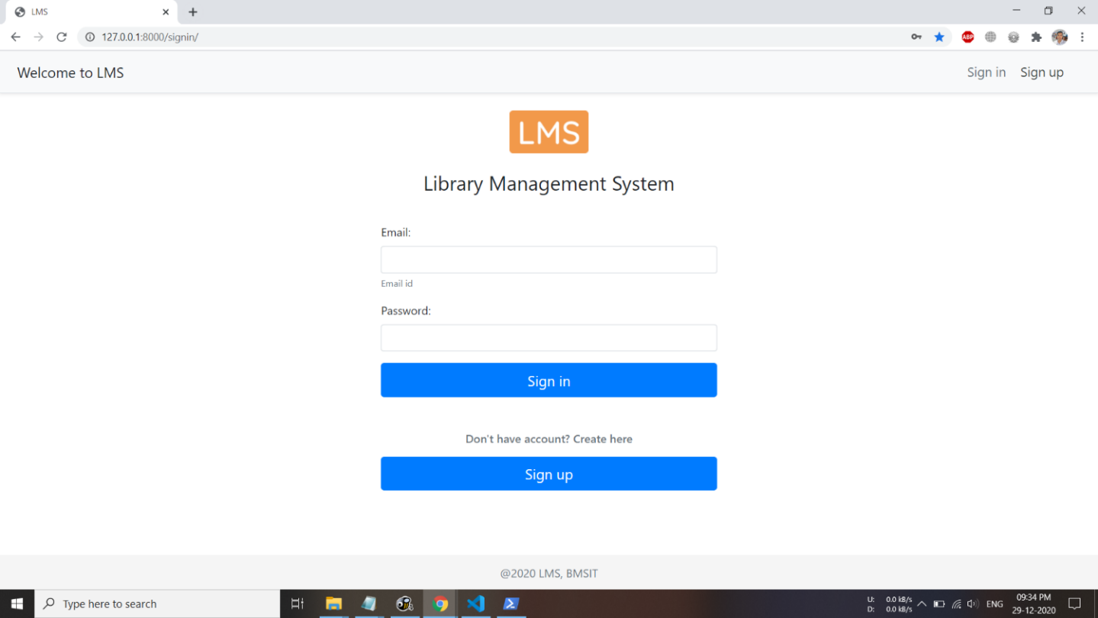

*Fig. 7.1 Login Page*

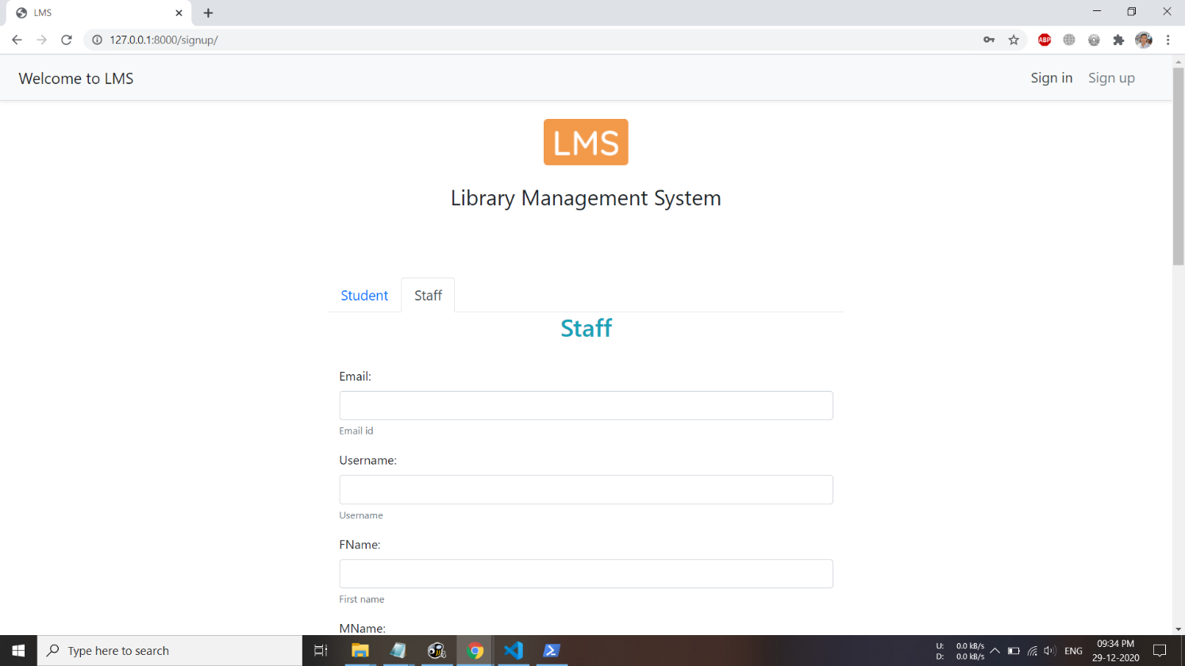

*Fig. 7.2 Registration Page*

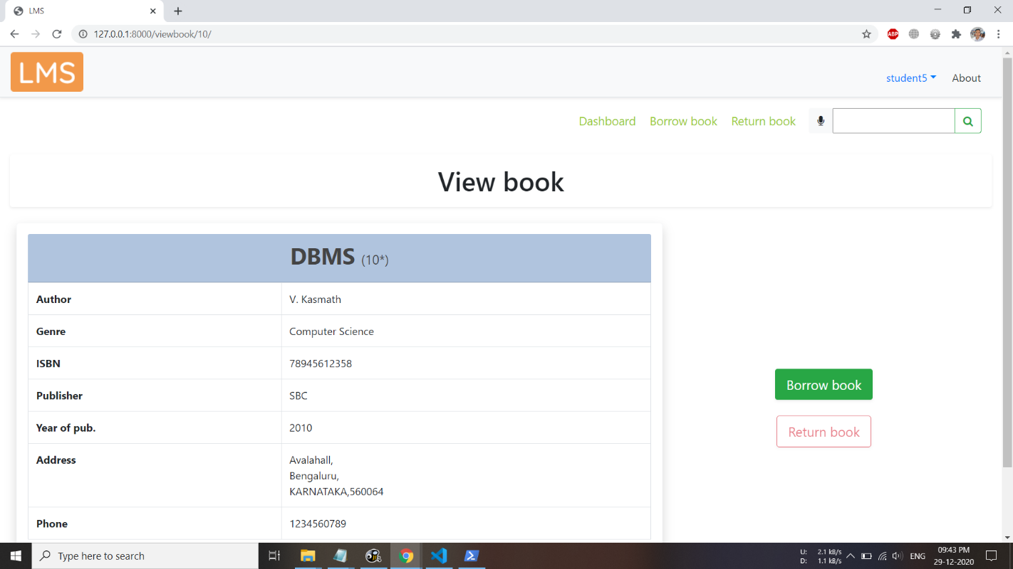

*Fig. 7.3 View Book page*

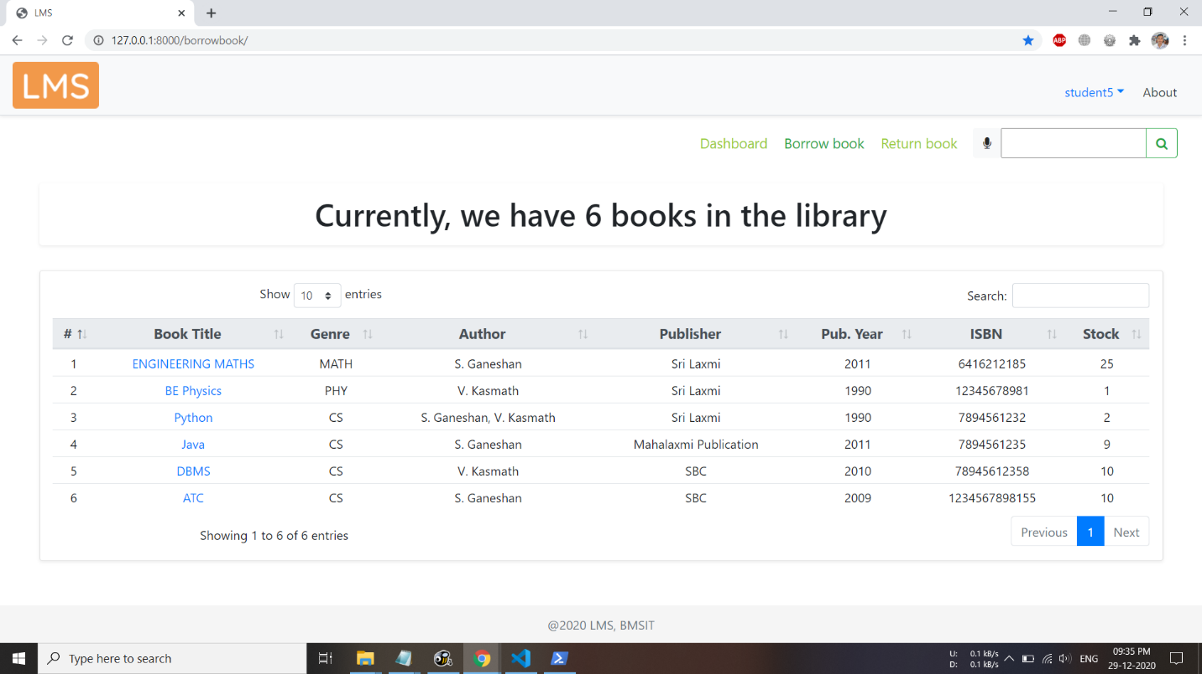

*Fig. 7.4 Borrow book page (Student login)*

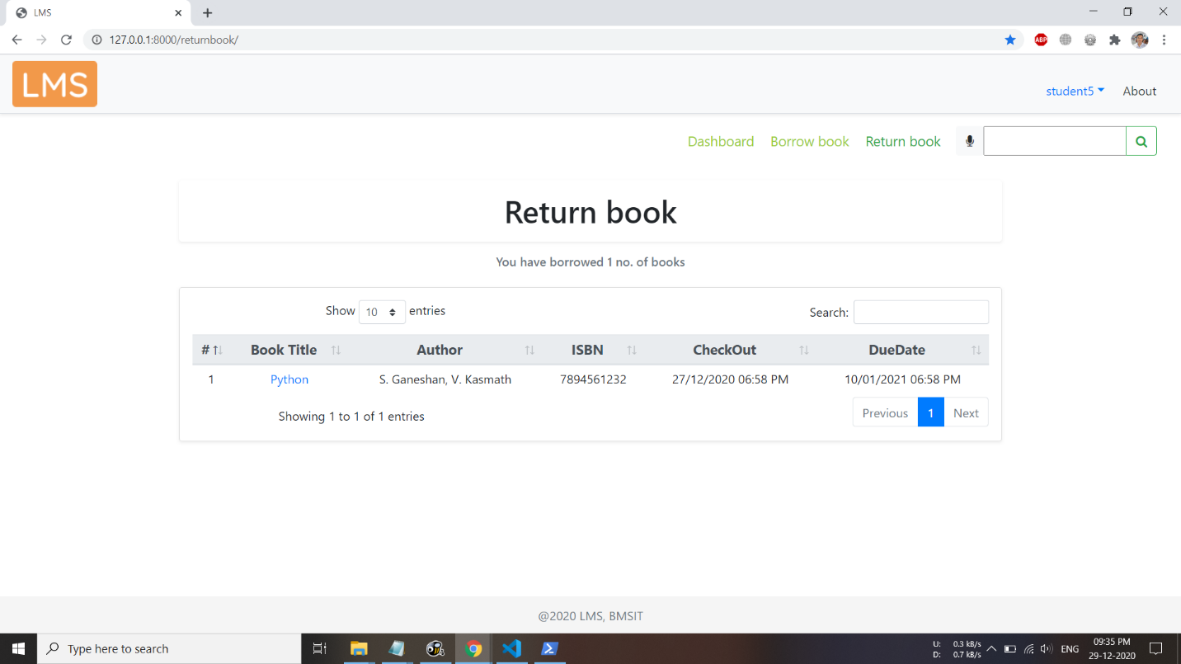

*Fig. 7.5 Return book page (Student login)*

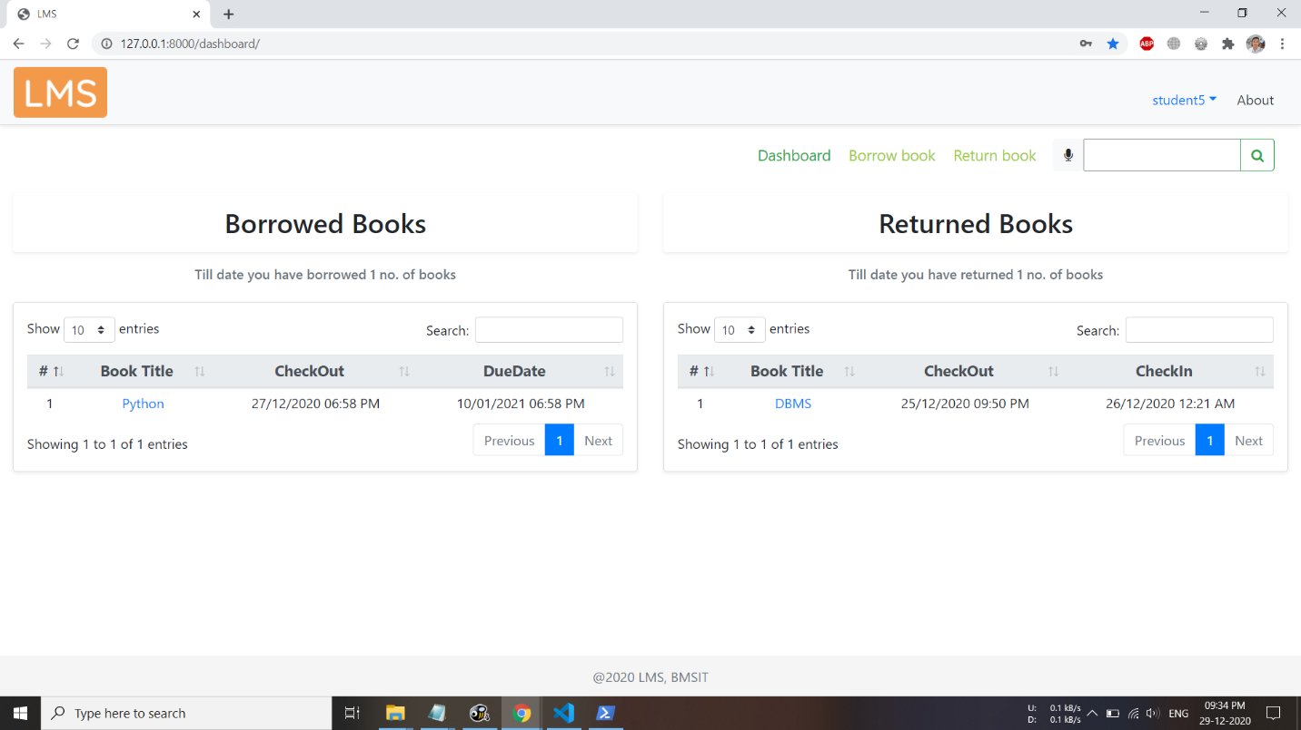

*Fig. 7.6 Dashboard page (Student login)*

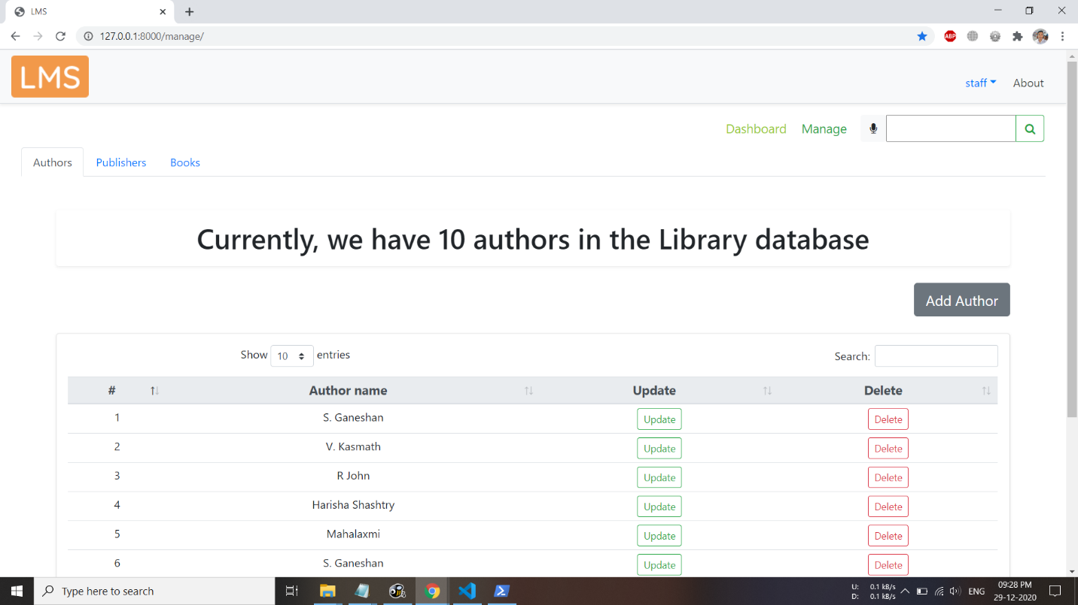

*Fig. 7.7 Authors tab in Manage page (Staff login)*

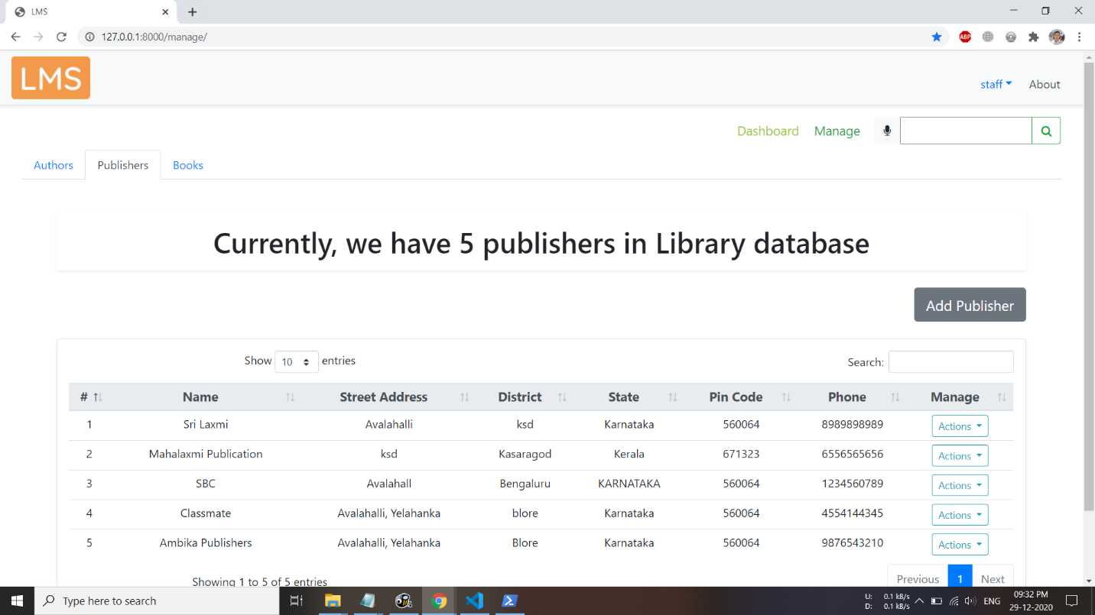

*Fig. 7.8 Publishers tab in Manage page (Staff login)*

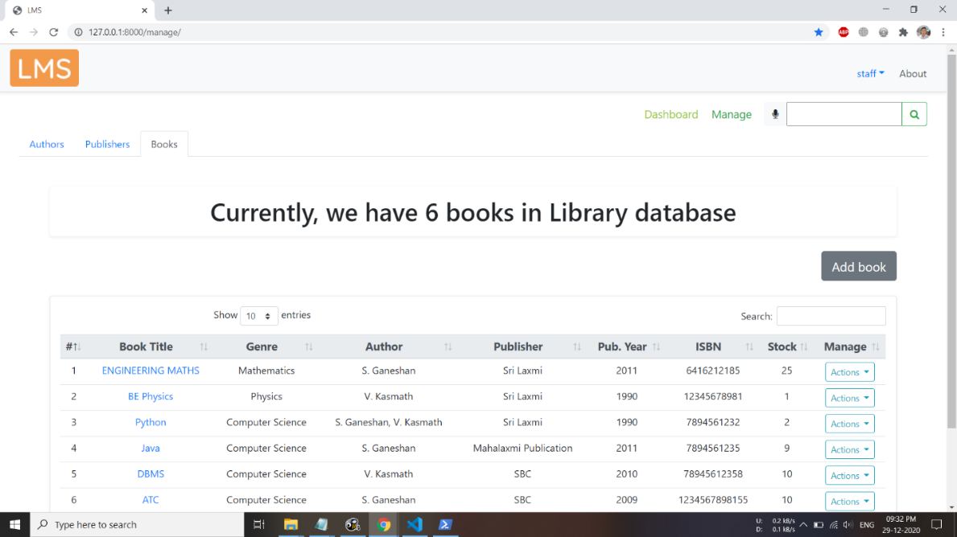

*Fig. 7.9 Books tab in Manage page (Staff login)*

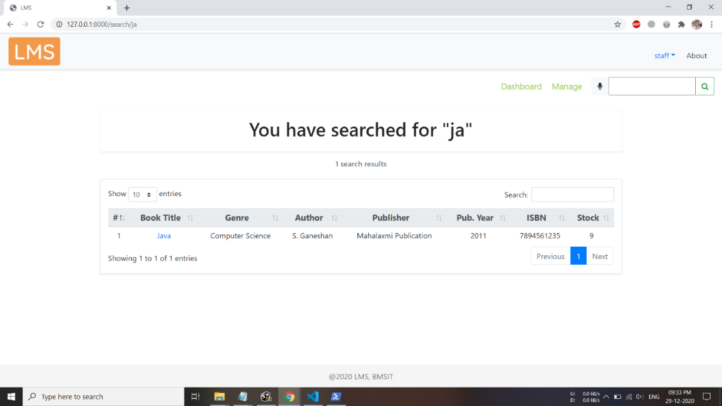

*Fig. 7.10 Search Results Page (Here searched for a book with name “ja”)*

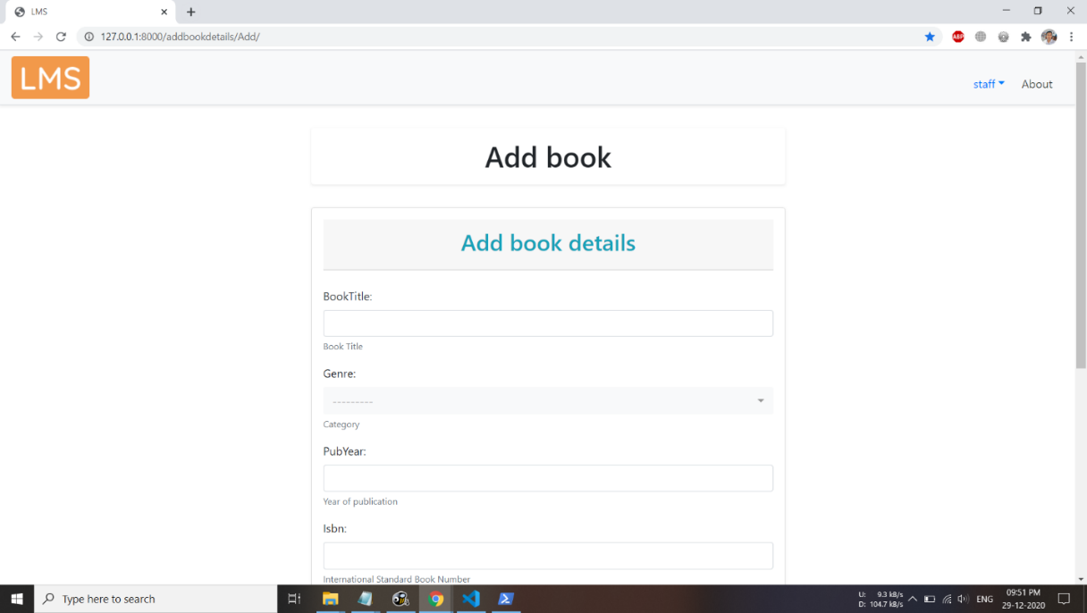

*Fig. 7.11 Add book page*

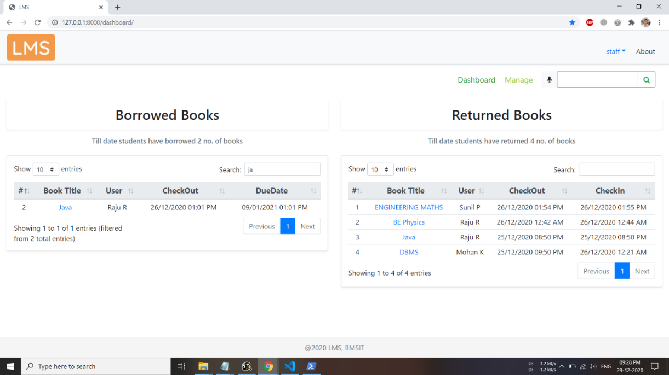

*Fig. 7.12 Dashboard page (Staff login)*

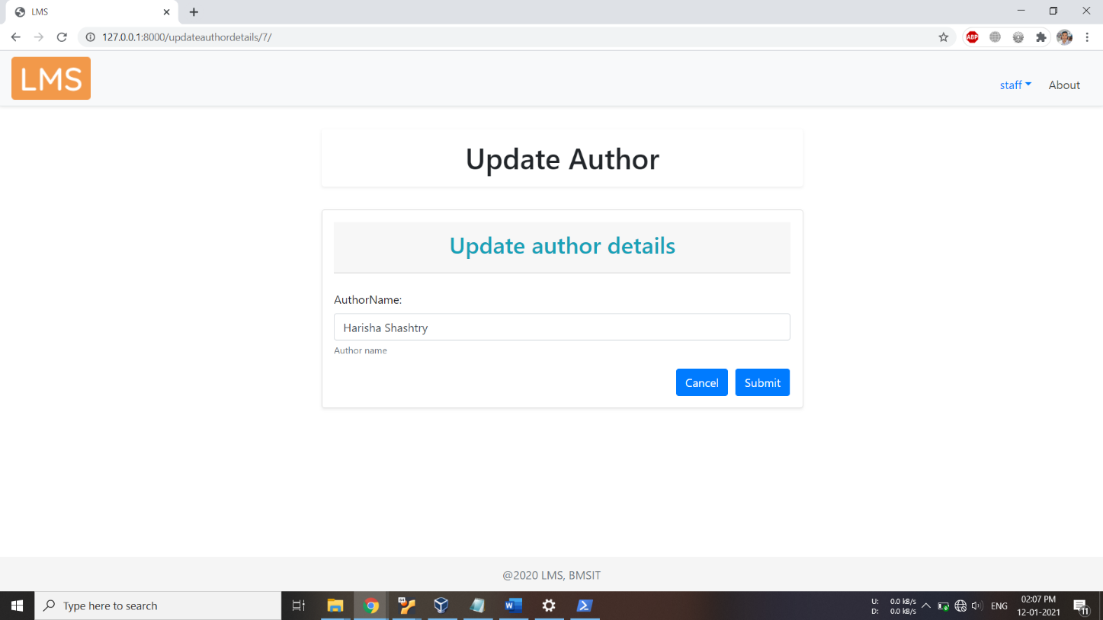

*Fig. 7.13 Update Author Page (Staff Login)*

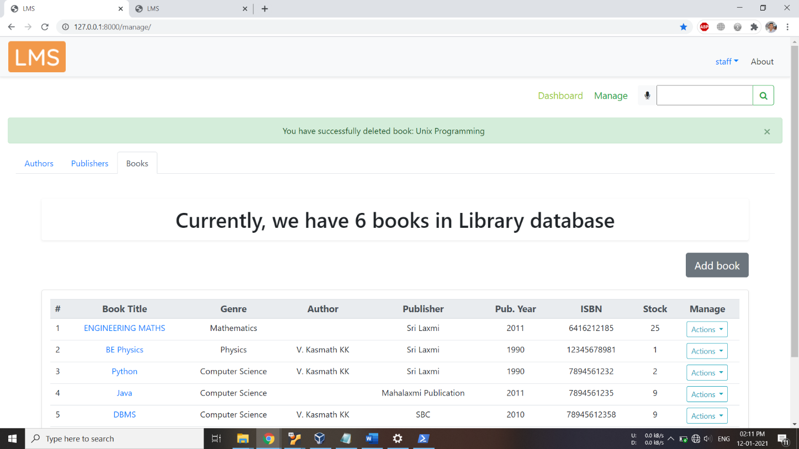

*Fig. 7.14 After deletion of a book*

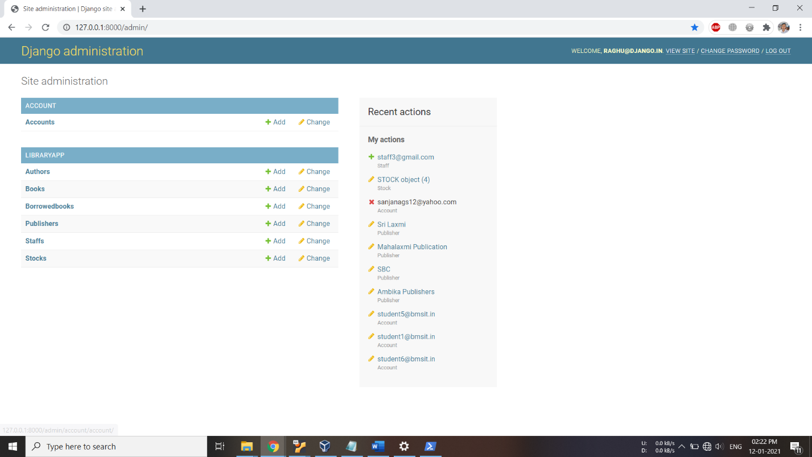

*Fig. 7.15 Admin Panel*

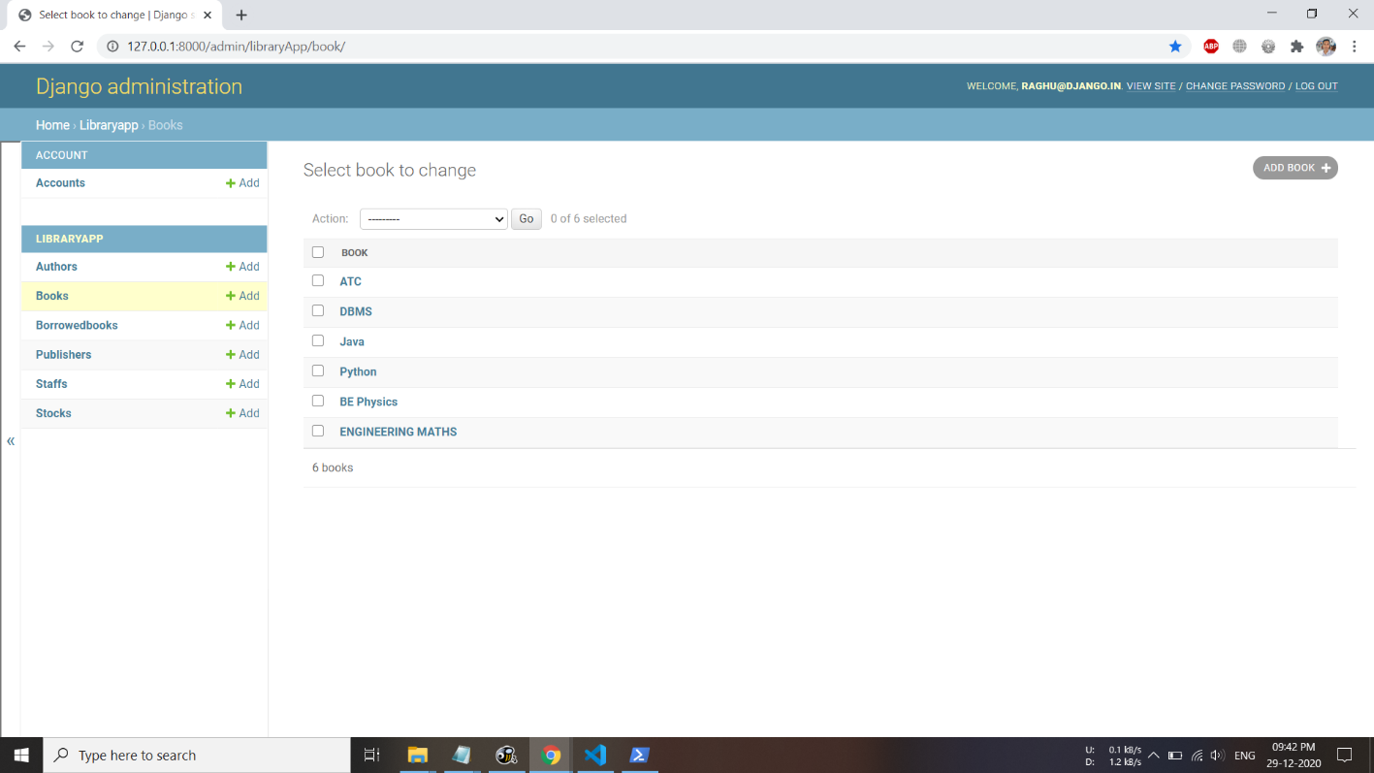

*Fig. 7.16 Records in BOOK Table*

**CONCLUSION**

An efficient technique has been developed in this study through which a user can easily locate the required book in the library.This Mini Project is for computerizing the working of a library.This software takes care of all the requirements of an library.It is capable to provide easy and effective storage of information related to books and users.

This software is not restricted to a college, it can even provide a solution for online rental of library services. In this project we implemented a Voice based book searching system. It will help visually challenged people to access their required books searched by their voice aptly.

**REFERENCES**

[1]. Fundamentals of Database Systems, Ramez Elmasri and Shamkant B. Navathe, 7th Edition, 2017. Pearson.

[2]. Database management systems, Ramakrishnan and Gehrke, 3"1 Edition, 2014, McGraw Hill.

[3]. Silberschatz Korth and Sudharshan. Database System Concepts, 6"' Edition, Mc-GrawHill, 2013.

[4]. Bootstrap Documentation: <https://getbootstrap.com/docs/4.5/getting-started/introduction/>

[5]. Django Documentation: <https://www.djangoproject.com/start/>

[6]. Building a Website with Django & Python (<https://youtube.com/playlist?list=PLgCYzUzKIBE_dil025VAJnDjNZHHHR9mW>)

[7]. Django (3.0) Crash Course Tutorials | Customer Management App (<https://www.youtube.com/playlist?list=PL-51WBLyFTg2vW-_6XBoUpE7vpmoR3ztO>)

**Department Vision & Mission**



**Vision**

Emerge as Centre of learning in the field of information science & engineering with technical competency to serve the society.



**Mission**

To provide excellent learning environment through balanced curriculum, best teaching methods, innovation, mentoring and industry institute interaction.

**Programme Educational Objectives**



PEO-1: Successful professional career in Information Science & Technology.

PEO-2: Pursue higher studies & research for advancement of knowledge in IT industry.

PEO-3: Exhibit professionalism and team work with social concern.

**Programme Specific Outcome**



1. Apply the knowledge of information technology to develop software solutions.

2. Design and Develop hardware systems, manage and monitor resources in the product lifecycle.

